##### 747 ­

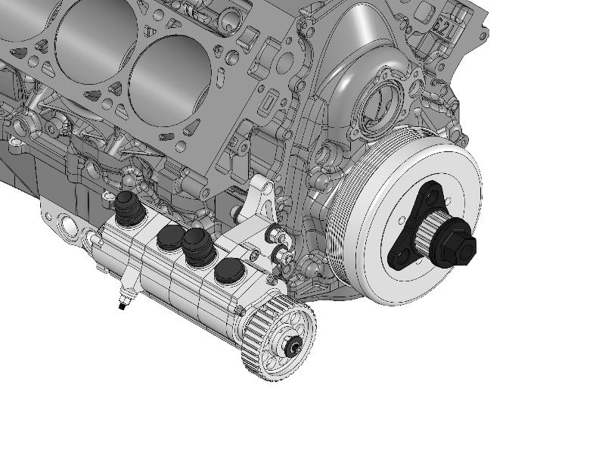

**14-3116**

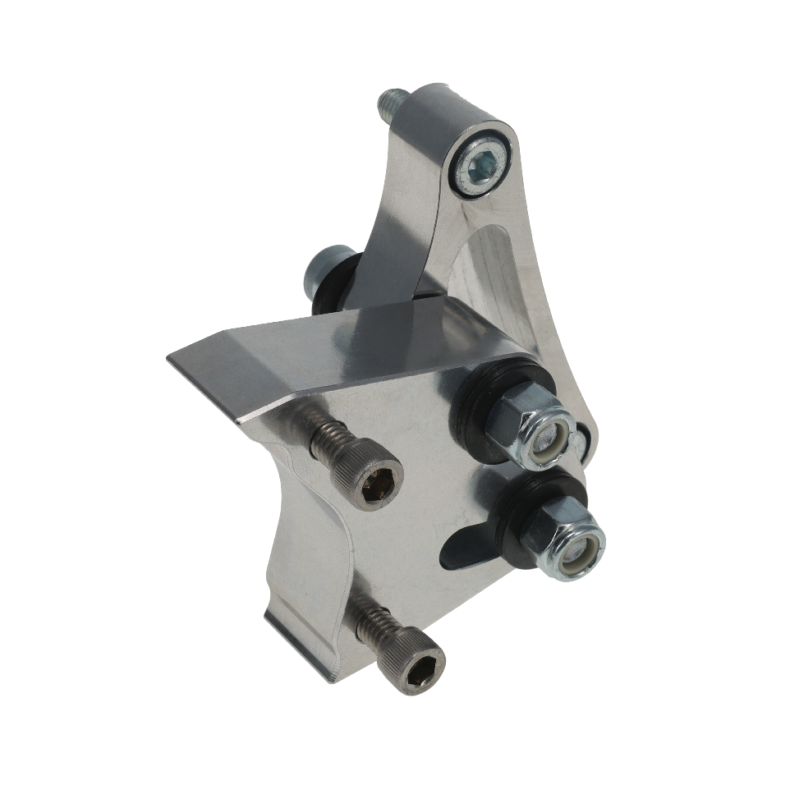

December 19, 2024

Press Release/New Product

**GEN V LT R4 PUMP MOUNT**

**Part No. 14-3116**

Use this Gen V LT engine specific mount kit to place a one (1) to six (6) stage R4 oil pump on the right side of the block. Mount kit includes all hardware necessary for installation. All Peterson oil pumps and mounting systems are manufactured in the USA and in-house from 6061 T-6 billet aluminum for reduced weight and superior strength. Kit includes billet mount blade and block adapter for positioning of the drive pulley forward of the harmonic balancer. CAD models are available to aid in system layout design upon request.

**Key Features:**

• Mount 1 to 6 stage R4 oil pump to right side of Gen V LT block

• All mounting hardware included

• Mounts off of front cover

• Includes belt tensioning

• Made in USA & machined Billet 6061 T6 Aluminum construction

|  |
| --- |
| **Pricing** |
| **For current pricing contact Peterson Fluids Systems at**[**pfsinfo@specprod.com**](mailto:pfsinfo@specprod.com)**or 800-929-7867** |

All pricing in US Dollars • ©2024 Niwot Corp. dba Specialty Products Company®

*4045 Specialty Place • Longmont, CO 80504 • 800-929-7867 • 303-287-1731 • www.petersonfluidsys.com*

**SSAVE OVER**

50%