##### 747 ­

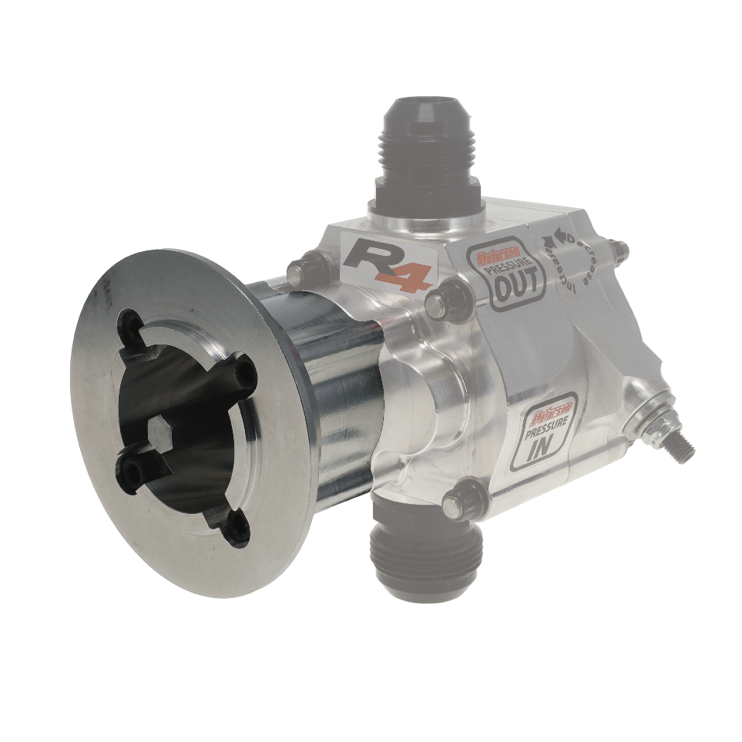

**14-2202**

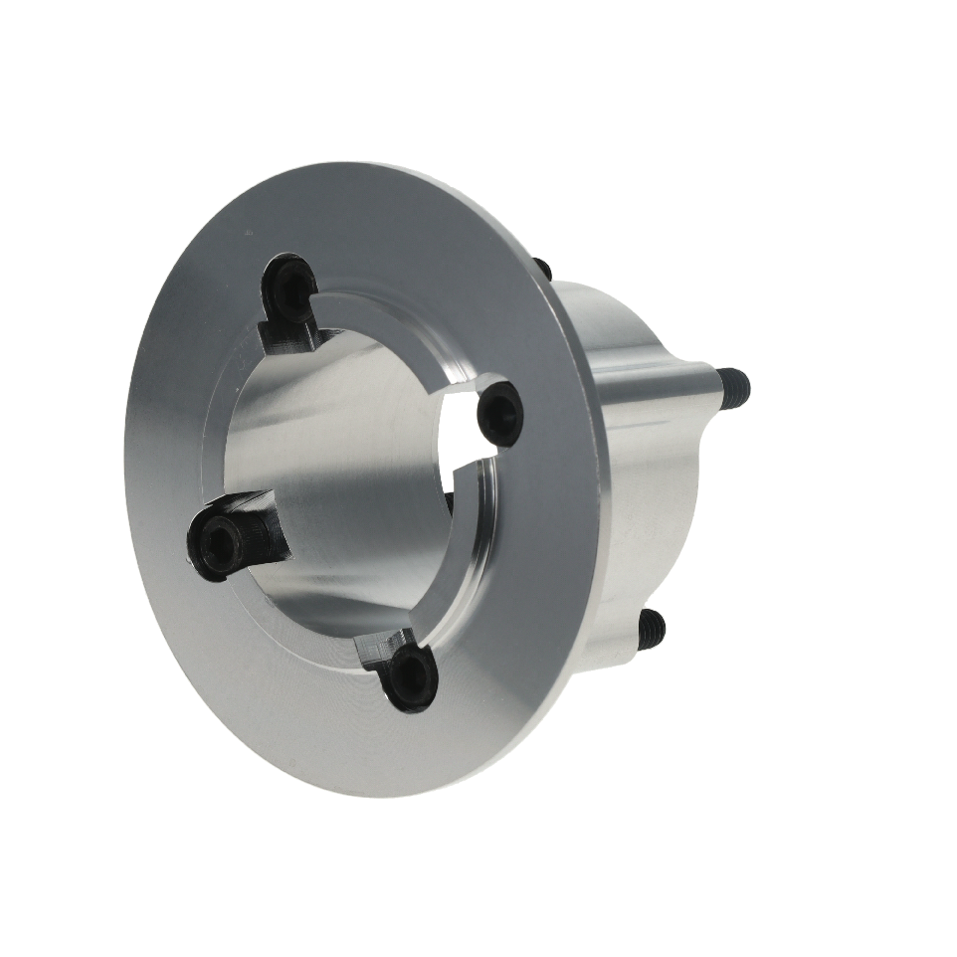

December 05, 2024

Press Release/New Product

**R4 V-BAND PUMP MOUNT**

**Part No. 14-2202**

Gain all the winning benefits of the Peterson Fluid Systems R4 oil pump with your Procharger accessory drive.  Crafted from 6061 T-6 billet aluminum for maximum strength, this adapter will work with 3/8" male hex drive or 5/8" keyway shafts and standard or reverse rotation oil pumps.  Requires Peterson R4 oil pump with front pressure section and is compatible with single stage wet sump and dry sump R4 oil pumps from 1 to 8 stages.  Six stage and larger pumps will require additional support for pump, contact Peterson Fluid Systems technical team for additional information.  V-band clamp not included.

**Key Features:**

• Mount 1 to 8 stage R4 oil pumps to Procharger accessory drive (6-8 stage pumps will require additional support)

• Compatible with 3/8 male hex or 5/8 keyway shafts

• Fits standard and reverse rotation R4 oil pumps with front pressure section

• Made in USA & machined from 6061 T6 aluminum

|  |
| --- |
| **Pricing** |
| **For current pricing contact Peterson Fluids Systems at**[**pfsinfo@specprod.com**](mailto:pfsinfo@specprod.com)**or 800-929-7867** |

All pricing in US Dollars • ©2024 Niwot Corp. dba Specialty Products Company®

*4045 Specialty Place • Longmont, CO 80504 • 800-929-7867 • 303-287-1731 • www.petersonfluidsys.com*

**SSAVE OVER**

50%